

Network Design & Management (IE 3010)

3rd Year, 1st Semester

Assignment

**Mail Server/Client Management**

Submitted to

Sri Lanka Institute of Information Technology

IT 18 1085 14

Wanigasekara.M.P.W.P.A

In partial fulfillment of the requirements for the

Bachelor of Science Special Honors Degree in Information Technology

<<01.05.2020>>

Table of Contents

1. **DHCP Configuration1**
2. **DNS Configuration4**
3. **Zimbra Installation 7**
4. **DHCP Configuration**

## Install and configure DHCP in Server machine

### **1.1.1** Install DHCP for configuration



#### Update OS

### **1.1.2** configuration by nmtui



#### Install DHCP

### **1.1.3** Select Edit a connection

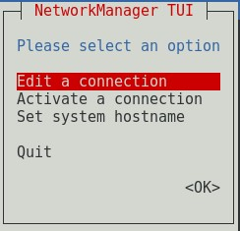

#### figur Install DHCP

### **1.1.4** Edit Wired connection 1 with Automatic IP configuration

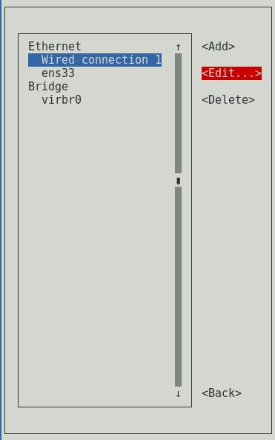

#### Edit Wired connection 1

#### Edit Connection and OK

### **1.1.5** Edit ens33 with Manual IPv4 configuration and go Back

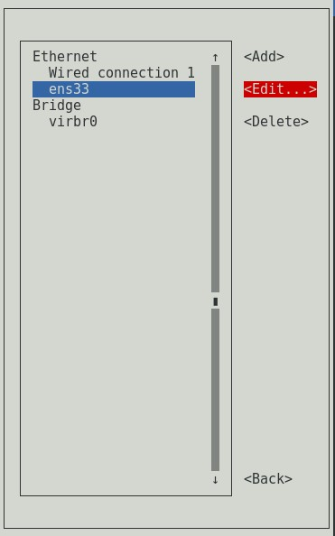

#### Edit ens33

#### Edit Connection and OK

### **1.1.6** Select Set system hostname and change the hostname as preferred

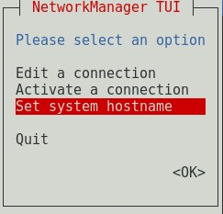

#### Set system hostname

#### Set Hostname and OK

### **1.1.7** Select Activate a connection and activate both network connections

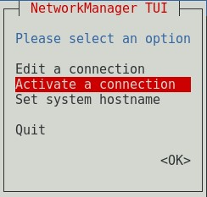

#### Activate a connection

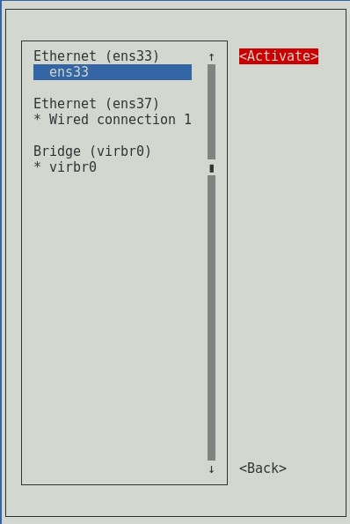

### **1.1.8** Click OK to exit from Network Manager TUI

OK to exit

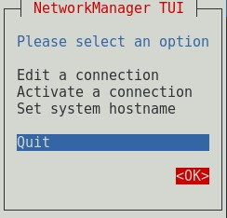

### **1.1.9** Check network configuration using ifconfig

Check network details

### **1.1.10** Open dhcpd file and add “DHCPDARGS=ens33” at the end of the file



Add network adapter details to DHCP file

### **1.1.11** Check dhcpd configuration file



Check DHCP configuration file

### **1.1.12** Copy the file to another destination. Click tab twice to show version number



### Copy DHCP file to another location

### **1.1.13** Open dhcp configuration file and edit



Open DHCP configuration file to edit

### **1.1.14** Check DHCP service status and start service

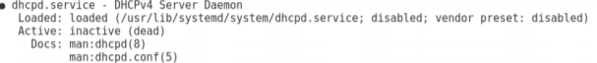

Check DHCP status

### **1.1.15** Start DHCP service and enable DHCP service to start at the OS startup



Start DHCP service





Enable DHCP to run at the startup

### **1.1.16** Check DHCP service status again



Check DHCP status

## Configure DHCP in Client machine

### **1.2.1** Following same procedure as previous open Network Manager with nmtui and Edit connection to Automatic DHCP

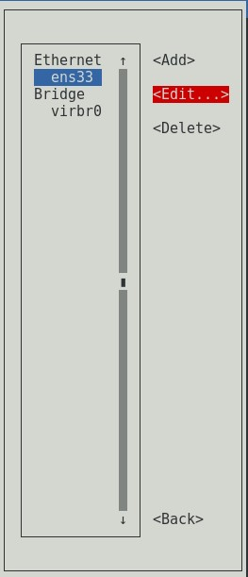

Edit ens33 connection

Edit Connection to Automatic DHCP

### **1.2.2** Change hostname as preferred and activate the connection

Set Hostname

Activate the connection

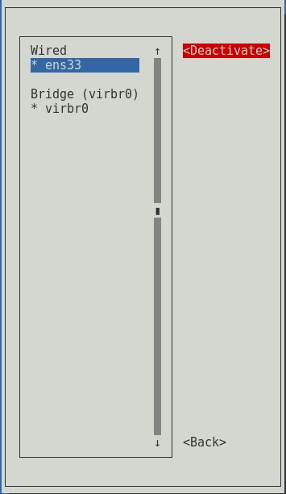

### **1.2.3** Check received IP with ifconfig through DHCP server



Check network connection